**EXPORTING CONTACTS AND CALENDAR FROM GMAIL WEB PORTAL**

# **EXPORTING CONTACTS**

1. Go to gmail.com and login with your appropriate credentials
2. You will be redirected to Gmail inbox page
3. Above the left navigation pane, you will see an option named **Gmail**

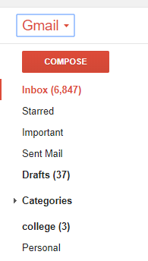

1. Click on the Gmail drop down and select contacts.
2. You will be redirected to Contacts page.
3. On the left navigation pane, expand the drop down **More.**
4. Now you will see an option named **Export.**
5. Choose the contact group you want to export.
6. Choose the export format **Outlook CSV (for importing into Outlook or another application)**.
7. Choose **Export**.
8. When prompted, choose **Save As**, and browse to a location to save the file.

# **EXPORTING CALENDAR**

1. Go to gmail.com and login with your appropriate credentials
2. You will be redirected to Gmail inbox page
3. On the top right corner select the **Google Apps icon**
4. Then select **Google Calendar** from available apps

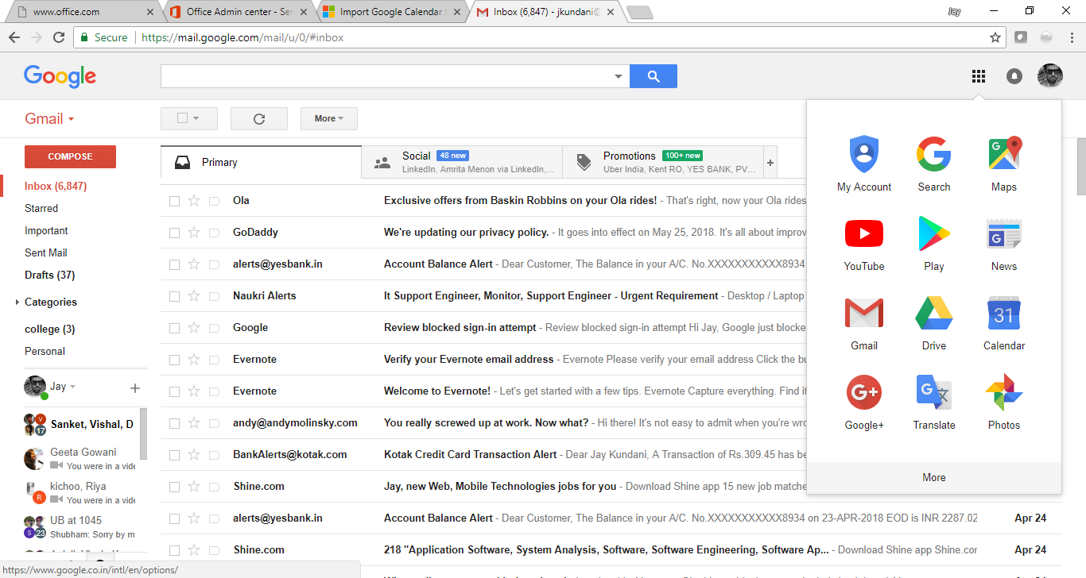

1. Choose **My Calendars** > **Settings**
2. Choose **Export calendars**.
3. Select a location to save the extracted file.
4. Go to that location and unzip the file: right-click the file and choose **Extract All**.
5. You have successfully exported your calendar.